**Open Question: Differences Between Groups of Patients Based on Age**

**Research Question**

How do the visual features of skin lesions (color, symmetry and blue-white veil) differ between various age groups?

**Motivation**

Understanding the differences in skin lesion characteristics across different age groups can provide insights into how melanoma and other skin conditions manifest in patients of different ages. This can aid in better diagnostic approaches tailored to age-specific presentations of skin lesions.

**Data and Methodology**

We analysed a dataset containing information about skin lesions, including visual features: color, symmetry and blue-white veil score. We divided the patients into five age groups: 0-20, 21-40, 41-60, 61-80, and 81-100.

To determine if there are statistically significant differences in the visual features of skin lesions between these age groups, we performed an ANOVA test for each feature.

**Results**

**1. Color Score:**

ANOVA Results: F-statistic: 0.480 p-value: 0.750

Interpretation:

The high p-value (0.750) indicates that there is no statistically significant difference in the color scores between the different age groups. This suggests that age does not significantly influence the color variability of lesions.

**2. Symmetry Score:**

ANOVA Results: F-statistic: 2.878 p-value: 0.026

Interpretation:

The p-value (0.026) is less than 0.05, indicating a statistically significant difference in the symmetry scores between the different age groups. This suggests that the symmetry of lesions varies with age.

**3. Blue-White Veil Score:**

ANOVA Results: F-statistic: 0.282 p-value: 0.889

Interpretation:

The high p-value (0.889) indicates that there is no statistically significant difference in the blue-white veil scores between the different age groups. This suggests that age does not significantly influence the presence of a blue-white veil.

**Visualizations**

To further illustrate these findings, we created bar plots showing the distribution of each score across the different age groups.

**Color Score Distribution by Age Group:**

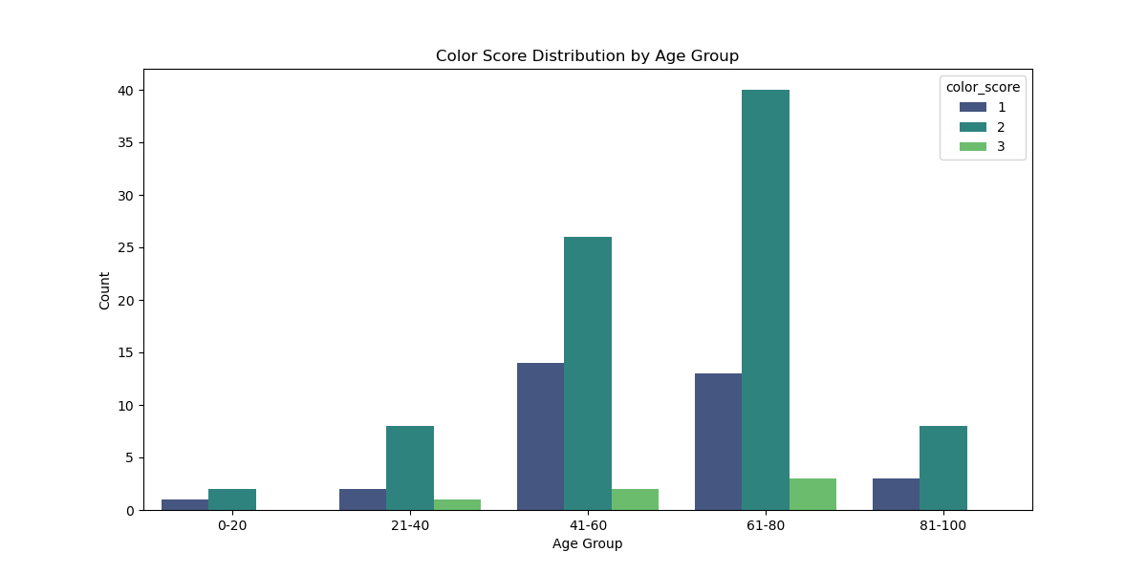

**Symmetry Score Distribution by Age Group:**

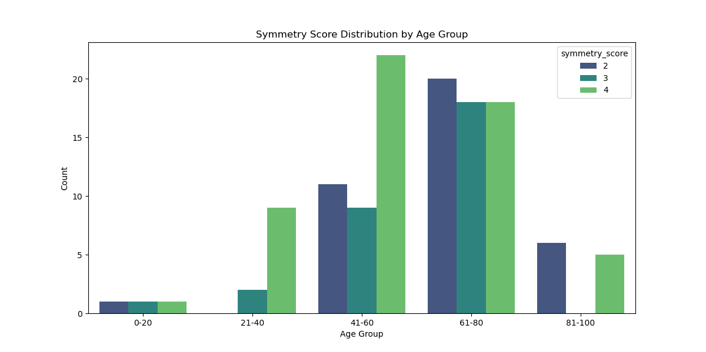

**Blue-White Veil Score Distribution by Age Group:**

**Discussion**

The findings indicate that while color score and blue-white veil score do not show significant differences across age groups, symmetry score does vary significantly with age. This could imply that as patients age, the symmetry of their skin lesions changes, which might be a relevant factor for dermatologists to consider during diagnosis.

Further investigation through post-hoc tests can provide more granular insights into which specific age groups have significant differences in symmetry scores. Additionally, other factors such as gender, smoking, and drinking habits can be analyzed to see if they contribute to differences in lesion characteristics.

**Conclusion**

The analysis reveals significant age-related differences in the symmetry scores of skin lesions, suggesting that age influences the symmetry of lesions. However, no significant differences were found for color scores and blue-white veil scores across age groups. These findings can help tailor diagnostic approaches and highlight the importance of considering patient age when evaluating skin lesions. Further research can explore other patient attributes and their influence on skin lesion characteristics.